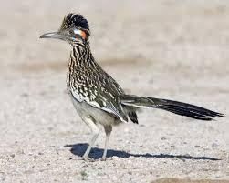Alfa Roadrunner

Winter 2017

Newsletter

Editor: Denise Gray [rvtreking@gmail.com](mailto:rvtreking@gmail.com)

**Officer’s Contacts:**

President: Jim Godfrey- [jim.godfrey@comcast.net](mailto:jim.godfrey@comcast.net)

Vice President: Chris Mooney -chris@moonsail.com

Treasurer: Becky Godfrey - [Godfreybj@comcast.net](mailto:Godfreybj@comcast.net)

Secretary: Barbara Leachman – [barb@moonsail.com](mailto:barb@moonsail.com)

**SOCIAL MEDIA:**

* Facebook.com/groups/AlfaRoadrunners
* https://groups.Yahoo.com/neo/groups/alfaseeya/info
* https://groups.Yahoo.com/neo/groups/alfaroadrunners/info

**WEBSITE ADDRESS:**

* www.Alfaroadrunners.net

**WORDS FROM THE PRESIDENT**

Good day Roadrunners.  Becky and I hope you are all having a great winter where ever you may be hunkered down.  Chris recently sent out an email about the website and registration for the Spring Rally.  We have received an update on registrations numbers for the AOC Rally from Andy and Brenda.  They are really down this year: only 79 rigs so far as of February 6th.  36 of those are Roadrunners.  The AOC Wagon Masters have extended their registration timeline to the 15th but must cut it off after that to get patches, etc. ordered and delivered.  So, if you plan on going to the AOC Rally, please get your registration in the mail.  If we don’t get more rigs, we may have to cut some entertainment.

Becky and I have looked at the registration listing for the AOC Rally and notice that many of you have registered for the AOC Rally but we haven’t received your registration for the Roadrunner Spring Rally.  We have approximately 27 Roadrunner registrations for the Spring rally as of Feb 6th.  We respectively request and encourage you to please get your Spring rally registration in to us soon and not wait until the last minute.

We look forward to seeing everyone soon.   If you have any questions or concerns, please let us know and we will do our best to address them.

Travel safe,

Jim Godfrey

President, Alfa Roadrunners

**VICE PRESIDENT’S and SECRETARY MESSAGE**

Your VP and Secretary have been busy working on the organization of the 2017 Annual Spring Rally (AOC Pre-rally). The dates are firm (April 2nd thru 5th), registration is open (deadline March 15th), and planning is continuing for the daily activities. If you have any suggestions for things you would like to do during the Spring Rally, please contact us.

Your VP is also your webmaster. The [www.alfaroadrunners.net](http://www.alfaroadrunners.net) website has been updated recently with photos from the Quartzite Rally, registration forms for the Spring Rally and the AOC Rally, and info about this fall’s Albuquerque Balloon Festival Rally. Please take a look at the updates when you can.

Our travels since the last newsletter have taken from Key West back to the Houston area where we spend our winters. We’ve made a few side trips to NY for Christmas and New Orleans in January (both by plane) and two weekends in Austin with the bus. At the end of February we’ll be heading to Arizona to begin prep for the rally.

We are looking forward to the Arizona rallies and hope to see many Roadrunners there.

**From the Treasurer**

Hello everyone, I hope everyone is having a great new year so far. Jim and I are so looking forward to seeing everyone and catching up on everyone’s travels. It has been a good year for us so far, just not enough skiing. My volunteering at the Area Agency on Aging cut back my volunteering hours to just 4 hours a week so I picked up a part time job working for a financial advising company, first working only 8 hours a week. Then they upped it to 16, and recently they have upped it to 20. I guess I should not try to be such an overachiever!! Anyway, it is beefing up our motorhome fuel account.

As the extended application deadline for the AOC Rally approaches, we have 43 rigs registered as of this writing. That is a great showing and by far the best (in my opinion) and largest group at the rally. We are also having a great showing at the Spring Rally. So far, we 35 rigs registered with a few more on the way that we know of. Jim has been busy assigning site to all the registrations and he says he will be sending out site assignments in March. So far, he tells me he has been able to accommodate everyone’s request for accommodations.

Again, we look forward to seeing everyone in April. Travel safe and if there is anything more we can do for you, please let us know.

Becky Godfrey, Treasurer.

**TECH TALK**

***12 V Dehumidifier for Storage - Dave Rypma, 2006 Alfa Gold 4078***

For several month during the winter in Florida, my coach sits in my community’s RV storage lot. I used to keep the bedroom windows open a crack and leave the roof vents open a bit as well so I’d get some flow-through ventilation. But the air in Florida is often damp and leaving windows open has always concerned me some, due to the high humidity. Last year, one of the window glass panes in the bedroom fell out at some time during storage. It was out long enough that some rain got in. THAT was the last straw! No more leaving windows open.

Humidifiers, at least the ones I considered acceptable, all need power. The absorption type that use a material that absorbs water need too much maintenance for this purpose. Some research led me to the Peltier technology dehumidifier. It uses a solid state thermoelectric module that gets cold on one side and hot on the other side when direct current (DC) is applied to it. I found the Ivation RSDM18 Mini Dehumidifier on Amazon (<https://www.amazon.com/Ivation-ERSDM18-Dehumidifier-Technologies-Efficiency/dp/B00RZVHB7M> at a cost of $59.99. Even better, this dehumidifier runs on 9 VDC, so I could use the coach’s 12 Volt battery bank as long as I had a 12 – 9 V converter (a Tusotek Buck/Boost converter available on eBay for $8.66). See <http://www.ebay.com/itm/DC-DC-Current-Boost-Buck-Converter-Power-Voltage-Regulator-6-35V-to-1-35V-5A-/321795754199>. Of course, you need to tap into the battery bank ahead of the disconnect relays so you can get 12 V power with the battery disconnects turned off! There’s a convenient place to tap into an existing easily-accessible wire in the BCC. You’ll need a crimp-on tap, an inline fuse-holder and some lamp cord or other flexible 16 ga wire to reach from the dash-located BCC to the sink where you will place the dehumidifier.

Since I have more than 400 Watts of solar panels on my roof, I had no concerns at all about the 27 watts that this device consumes (just over 2 amps). If you don’t have solar on your RV, you’ll use up the combined house and inverter batteries in 150 hours (6 days), so not practical if you’re not plugged in or not using solar.

This dehumidifier removes up to 12 ounces of water a day, which is sufficient in a closed up coach to keep it dry. But for this to work, you need to add an external drain hose and let it empty into the sink. At 12 oz per day, I’m not too concerned about the grey tank filling up! Mine has worked well for the last 3 months.

Here are some pictures of the unit, its installation and the connection to the batteries (in the BCC).

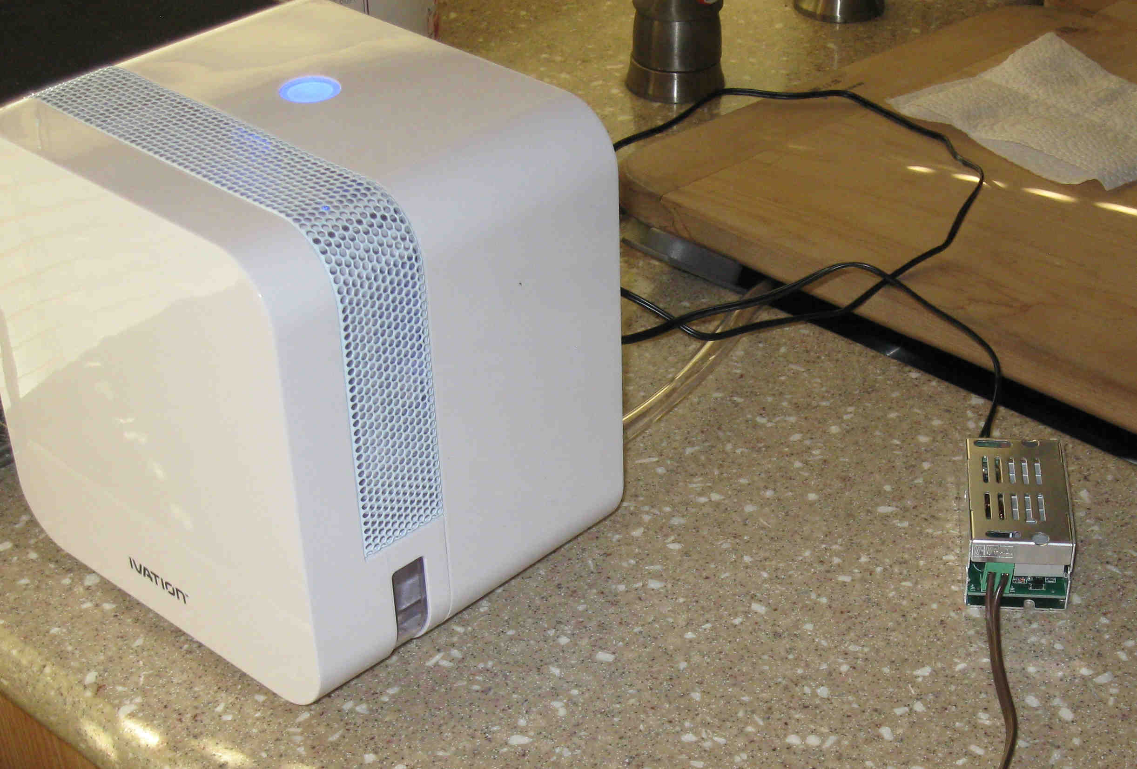

Front of dehumidifier in operation

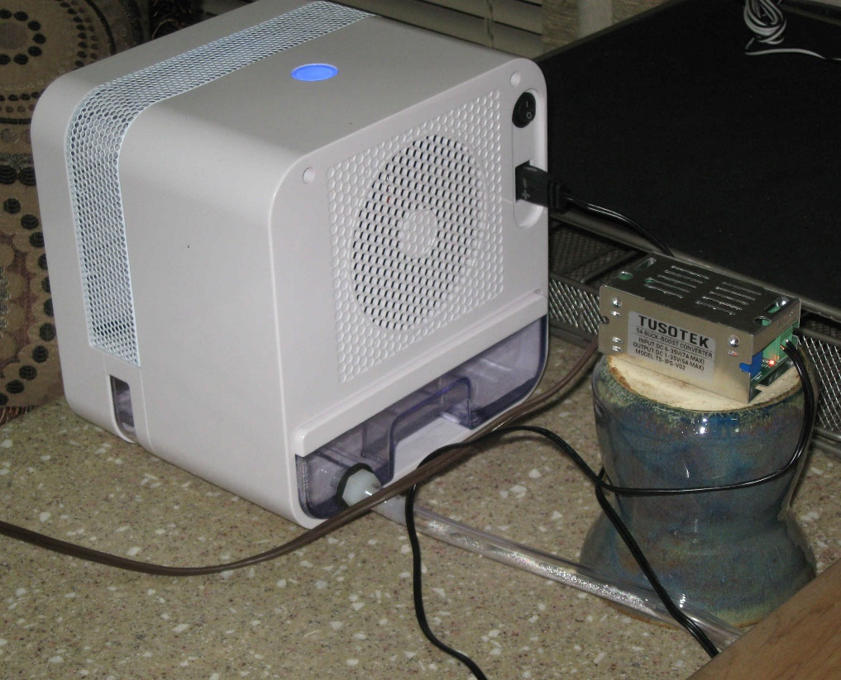

Rear of dehumidifier shows the added drain hose going into the sink. The converter is sitting on top of an inverted mug so that the airflow from the fan keeps the converter nice and cool. I was operating it without the airflow and it got a bit warm. Note the lamp cord snaking off to the left and going up to the BCC.

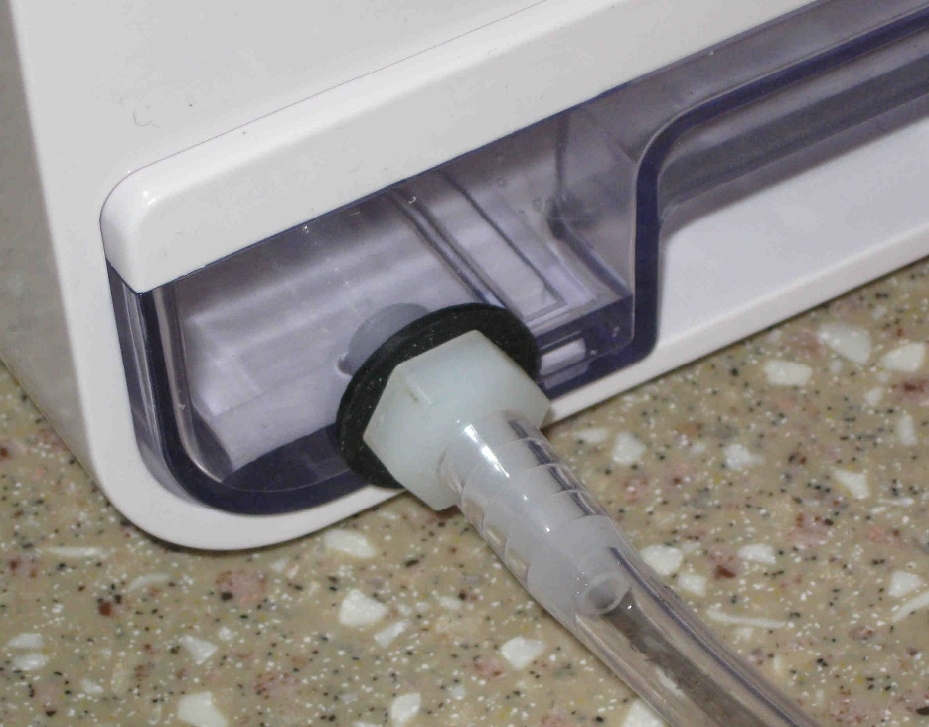This photo shows the detail for the added drain hose. The tray doesn’t come with a drain and will only hold 22 oz. I drilled and tapped the tray for a 1/8” NPT nipple, added a 2/8” hose and the barb as well as a rubber washer on the threads of the nipple. Use an 11/32” drill and a 1/8” pipe thread tap at the bottom of the tray.

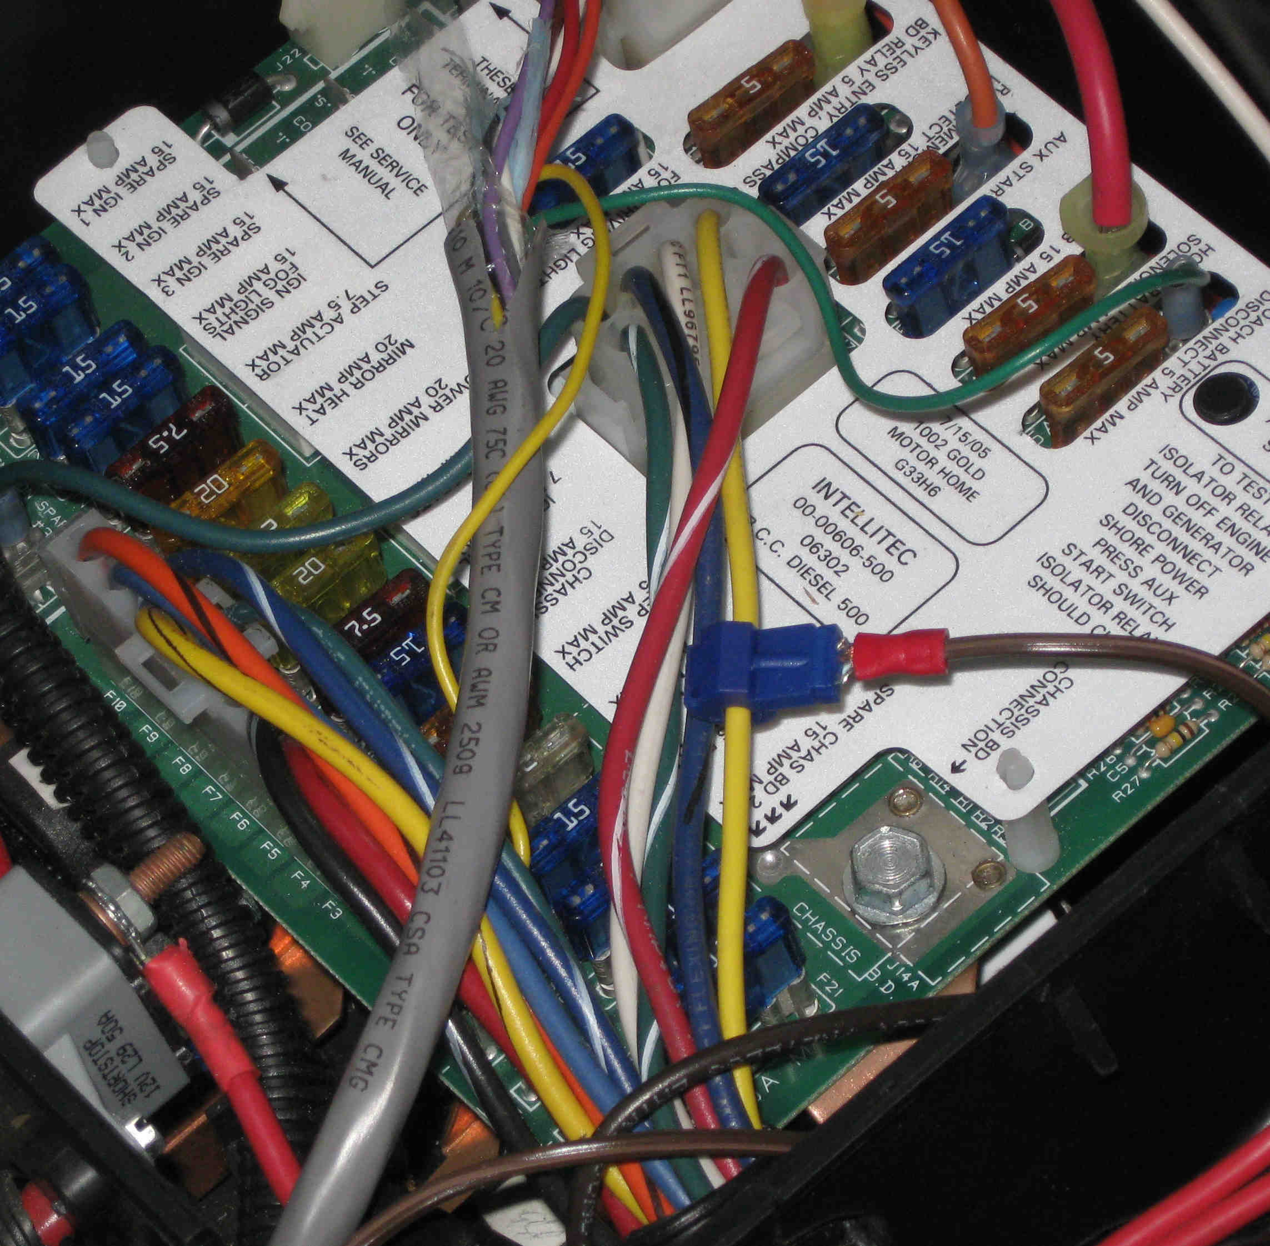This picture shows the wire connection I made in the BCC. Note the yellow wire coming from the top left corner of the large connector in the center of the BCC board (J4 Pin 3). I used a 16-14 Gauge female T-Tap Connector available from wiring suppliers (Amazon, Del, eBay all sell them, probably also auto supply places).



A wire with a male spade lug on the end will connect with this T-Tap connector. Although it might be safer to also add an additional pigtail fuse holder on the wire, that wire is already protected by fuse F18 which may be labeled “Solar”. It is connected to both house & chassis batteries through diodes. If you have your house & inverter banks combined, includes the inverter batteries. So, BE SURE you have a charging source or chassis bank can die!

**Albuquerque International Balloon Fiesta 2017 (AIBF)**

<http://www.balloonfiesta.com> Oct. 7th through Oct. 15.

We are going to repeat last year's gathering, hope you will join us.  This will be a volunteer rally requiring at least one person from each coach agreeing to volunteer for AIBF.  We will meet at Enchanted RV, just west of Albuquerque on Wed. Oct. 4th and caravan into the Fiesta grounds on the morning of Oct. 5th to be parked together as Navigators (AIBF term for a volunteer).  Fiesta dates are Oct. 7th through Oct. 15.  Many of us will wait to depart Fiesta grounds on Oct. 16th due to heavy traffic.  There is required on-line training (informative and easy) and quizzes.  Depending on the number of hours volunteered, Navigators may earn nice perks (clothing and discounted/free camping).  As Navigators we are treated to several special meals, have a dedicated on-field Navigator area for viewing/warming and snacking.   We receive passes to the Balloon Park for admission and parking.  This is a DRY Camping event, but don't worry, we will be offering tips and tricks to help you enjoy this experience and water/pumping services are available for a fee.  Hope you will consider joining us - we have limited spaces available, so get your name on the list if you are interested.  Send me an e-mail or call me for more info.  Wagon Master:  Susan Prichard - [rvgrandma01@gmail.com/480-495-4645](http://rvgrandma01@gmail.com/480-495-4645).

**NEWS FROM OUR FELLOW ROADRUNNERS**

***Deanna & Frank Jones***

Frank and Deanna decided to go to the East Coast this winter & spend part of the winter in FL. Our path got diverted some by Hurricane Mathew.  This year was our history trip. We saw some of the buildings in Washington, DC and enjoyed the Smithsonian Natural History Museum the most. Since we have seen so much in AZ about the Native Americans & gardens in other cities, we were disappointed in the Native American museum & the National Garden. We enjoyed a few other historic cities from Abingdon, VA & Fredericksburg & Wilmington & Lexington & Savannah. These cities covered both the Revolutionary & Civil Wars.

We were in FL two years ago & found prices had really increased & more parks are requiring 1-3 months stays.  We found it difficult to find places to stay as we moved around so we had to make reservations much more than we prefer. So far we have spent time in Ocala & Everglades Midway regions in FL. The weather has been very mild & pleasant this year. The humidity is lower than 2 years ago and temps in upper 70s & into 80s. FL is expensive & very crowded & getting harder to find places to camp without making reservations months to a year ahead. More baby boomers are retiring & hitting the road. We both miss AZ & our AZ camping friends & Deanna’s nieces/nephews in the SW. So next year we will likely go back there in the winter. We will be heading north slowly & get to MO by mid-March. Deanna is planning on getting cataract surgery in April or May in her second eye.

We have been full-timing since 2002—2 years in pop-up & rest in our Alfa See Ya. Deanna is finding it harder to full-time so she is advocating that we settle down & become snowbirds with local camping trips at Core of Engineers & State Parks in MO, AR, KS & OK during the summer. Deanna wants to spend more time with family in KC area, do some volunteering & maybe join a quilting & Democratic groups. So 2017 may be a year of compromises & change. Frank is not in the same place related to full-timing.

***Bob and Denise Gray***

We have been traveling through Florida this year. We visited the east coast, then went to the Thousand Trails in Clermont for 2 weeks of Disney resort and visiting friends in the area. We continued down the east coast, settling for a month on Sunshine Key. We continued our trip up the west coast of Florida, spending Christmas in the Sarasota area, where we visited the Ringling Mansion and Circus Museum. We also watched the Lipizzan Stallions in training!

We returned to Clermont, this time visiting the Universal Theme parks and visiting with Barb and Sid Zelke, who hosted two Alfa happy hours. We followed the Zelke’s south to the Tampa State Fairgrounds to attend the Alfa Sunrisers mini rally. We were welcomed with open, Alfa arms, joining fellow Roadrunners Frank and Deanna Jones.

We are continuing our travels, visiting the east coast, again, to see the places that we missed due to Hurricane Mathew. We start our trip west on Feb. 12. We will see you all in Tucson in April!

***Robert and Jo Mellis (2008 Alfa See Ya).***

We've spent our winters for the last seven years as volunteers in the Florida State Parks system. These have resulted in a treasure trove of different experiences and we thought you might find the information to be useful.

As the years progress, we have narrowed our range of parks to a favored few. But we have volunteered as places as widely divergent as Zachary Taylor State Park in Key West where we experienced the madness of Fantasy Fest (last week of October) to the sublime beauty of Honeymoon Island State Park in Dunedin, FL. Mile after mile of sugar-sand beaches and acres of picnic areas make this the busiest day park in the state.

We have found exquisite beauty and peace in Highlands Hammock State Park in the middle of the state. There, we'd open the park and patrol the back country, visiting with hundreds of black vultures and alligators, water moccasins, exotic birds and thousands of cypress knees that poke out of the swamp.

We are drawn to the ocean because the first seven years of our retirement involved sailing 15,500 miles numerous time from the Canadian border to the hundreds of uninhabited islands of The Bahamas. So we are drawn constantly to parks like John Pennecamp in Key Largo - in the northern Keys, as well as to Lover's Key, south of Fort Myers Beach. When we take up residence there, our tasks usually involve driving the tram that moves visitors from the parking area to the spectacular beaches. Along the way, we entertain the visitors with descriptions of the bald eagles, osprey, roseate spoonbills, kingfisher. Northern visitors - as well as those from Europe are in awe at the bird life that's often unique to the west coast of Florida.

Couples who volunteer are expected to put in a variable number of hours (depending on the park). We work a combined 20 hours a week at one park. Others require 32 hours a week to earn a site with full facilities. We enjoy the camaraderie with the other volunteers as well as the rangers. In our experience, volunteers are generally perceived as a great blessing to the park staff because the state keeps the paid staff pretty thin. Volunteers provide more than a million hours of work each year to make the park system work.

If you wish to apply, click and it should take you to an electronic application. <http://volunteers.floridastateparks.org/pages/app:INDIV>

Remember, wintertime is very popular among northern volunteers so it's hard to find a slot. But if you start out in the late spring, summer or fall, you are much more likely to find available slots. In addition, it allows you to dip your toe in the system to see if you like the experience. It also allows you to build credibility since all the volunteer coordinators work with each other throughout the parks system to provide references.

New blog is at: <http://robertsmellis.blogspot.com/> New pictures <http://mellis.shutterfly.com/>

**My book, Now, We Begin, is available for only $4.99 at:**

For eBook: [http://www.amazon.com/Now-We-Begin-ebook/dp/B006NYDO00/ref=sr_1_1?ie=UTF8&qid=1324938959&sr=8-](http://www.amazon.com/Now-We-Begin-ebook/dp/B006NYDO00/ref=sr_1_1?ie=UTF8&qid=1324938959&sr=8-1)  or <https://www.smashwords.com/books/view/113915>  Print version  <https://www.createspace.com/3728363>

**2017- QUARTZSITE -Quartzsite Rally Wrap-Up**

*Ray and MaryAnne Balzer, Wagon Masters*

It was the best of times, it was…..interesting times. The 2017 Quartzsite Roadrunner Rally was chock-full of fun and wild weather; spending time with friends at potlucks and activities, or hunkering down with no social hours and no evening fires. Good thing for the potlucks in between weather events! The rally was attended by 50 of us in 26 rigs.

The rally began Friday January 20th, but weather delayed any events until Saturday. Thanks to clear skies and reduced breezes, we were able to all get out and visit over heavy hors d’ oeuvres and enjoy our Roadrunner 30 years as a club Celebration Cake. Our longest time member Bud Serpa did the honors as ceremonial cake cutter.

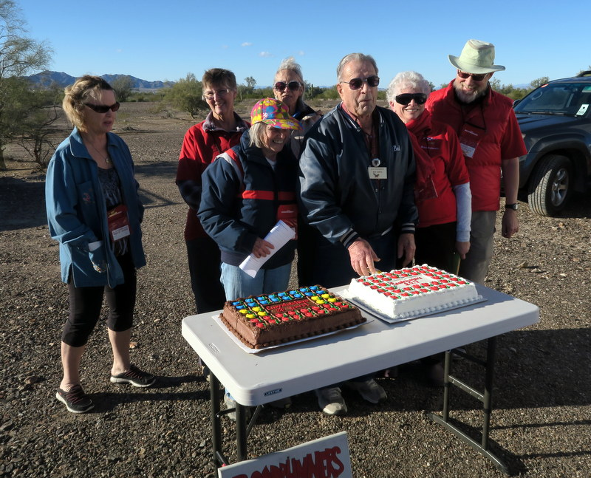

Sunday morning as weather was settling in again, we held our first yummy breakfast potluck. The theme was perfect for the colder morning—baked breakfast casseroles. During the breakfast, Joe the Glass Boss came by to chat with members needing services and to take orders. Afterwards, a number of us, led by Sharon Tisdale, held an open craft and coloring time until once again the weather came in.

By early Monday morning it was clear Quartzsite was going to be in the path of another series of incoming storms. And not just Quartzsite, all of Arizona and So Cal experienced these rounds of storms. So we researched weather patterns, crammed information from a number of websites and quickly drew up a revised Monday through Sunday morning schedule. We then hand delivered copies to attendees. From then through the week we used text messaging to refine and expand on the schedule information, or personal contacts as we could, given the conditions.

Despite weather, a rally full of activity get-togethers and potluck meals was enjoyed. We shared a chili cook-off with prizes and a BBQ dinner and potluck. The Wagon Master’s Dinner was held on Tuesday night after several days of very un-Quartzsite like weather. The only event canceled was the potato bake potluck. The winds howled that day, so no fire or outdoor activity was possible. The Quartzsite food bank benefited though, they very gratefully accepted our bags of charcoal as a donation for their clients without cooking facilities.

One event was held-off from the printed schedule as a floater. We were waiting for the warmest, lowest breeze afternoon to hold our ice cream sundae social event. We were finally able to enjoy our sundaes on Saturday just past mid-day. And boy did ice cream and brownies taste wonderful out in the warm sun!

The Sheriffs Dinner events were held right on time, Saturday afternoon and evening. Our surprise Sheriffs this year were both Charlie and Paula Gray. Paula recited our misdeeds, real or imagined (3 pages!), while Charlie made the rounds as collector of fines. Thank you Charlie and Paula and all attendees for the fun, and contributions for the Quartzsite Food Bank! This year we raised $211! A check was delivered and a receipt letter will be mailed and presented to Roadrunner officers at the Spring Rally.

Not to be overlooked, this year we had a road trip picnic to scenic Crystal Hill about 15 miles from the campsite. About 20 of us attended the outing and enjoyed the provided picnic. Also, following the Wagon Master Dinner, Ray and our guest Sue Dusenberry conducted a first time to us game, an adaption of ‘I’ve Got A Secret’ to help us get acquainted with each other. Given fewer social get-togethers this year, it was a fun activity learning more about each other in a short time. We thank everyone who participated, providing little known facts about themselves.

Also, one afternoon Mac the Fire Guy was able to present his fire safety class and firefighting demonstration. Lana Caterson and Hazel Ahmad braved the conditions to demonstrate fire extinguisher operation. Another weather permitted morning, Dale Prichard led a very informative and well attended Tech Talk. One breezy morning an open coach event was held, featuring six coaches.

As a change, this year we purchased fewer bakery donuts. Instead, we suggested sharing ‘breakfast treats’ (breads, cookies, etc) on mornings we did not have a potluck and weather permitted. And besides the breakfast potluck already mentioned, we were able to have two others, one being our famous Quartzsite Pancake potluck. Our thanks to Sven Novion and Bud for their expert flipping skills, and Sharon Novion for all her batter beating!

Very special thanks to Leigh Gushea for her fabulous Treasurer assistance. As well as John Gushea for helping Ray with road signs and support. Also, the Novions for helping us with food and once again providing tables, tarps and equipment for the potluck area. Another big thank you to Susan Prichard for representing the Roadrunner officers and taking care of all official club business. As well as the donut pick up along with Sharon.

There are so many thank-you's to all the wonderful cooks, the BBQ grill masters, and for all the food that appeared as if by miracle on the tables.

Another special thank you to all those who built and maintained and then doused our camp fires, when weather permitted fires. We are very thankful for all the work and the attention you had to give so the rest of us could keep warm and visit longer.

We want to thank everyone who attended the rally for their cooperation, participation, and patience with us as we had to do and redo and change again the rally schedule on the fly. Given the restrictions created by the weather, we tried the best we could to provide a fun and full rally. It was certainly a year we will all remember!

And, it was terrific to be able to offer text messaging and to hear back via text, all for the first time in Quartzsite this year. Weather made communication difficult. Texting helped us keep in touch during this first time in decade’s weather event.

We were truly happy for the opportunity to serve as your 2017 Wagon Masters. Now, Quartzsite 2018 is in need of Wagon Masters. Dale and Susan Prichard have volunteered to be your assistants. Will you consider volunteering?

**GET-TOGETHERS**

**Mesa AZ MOAB (Mesa Owners Alfa Breakfast)**

The dates are:

11 February 2017

11 March 2017

8 April 2017

Breakfast starts at 8:30 am at the Golden Corral, 1868 N. Power Rd,, Mesa, AZ – 85205.  Their phone number is: 480-985-6793. Call John: 612-965-5762 or

Email: [johntsr641@gmail.com](mailto:johntsr641@gmail.com)

**Phoenix Westside Alfa Group**

The third Wednesday of each month all year, 8:30 AM at Trivoli Gardens. Located at **12535 W Bell Rd, Surprise, AZ 85374. Contact Linda Rees 623-236-4061. Or** [lindar@outdrs.net](mailto:lindar@outdrs.net)

**Yuma, AZ**

The Yuma Alfa Owners Breakfast is the second Monday of the month, November through April.  All Alfa owners, past owners, and want-to-be’s are invited.  It’s a great time to meet and greet, catch up on the goings on, and discuss the care and feeding of Alfa MH’s and Fifth-wheels.

The Yuma Alfa breakfasts are held at the Copper Miner Restaurant (formerly Mi Fajita Restaurant), 11375 Foothills Blvd., Yuma, AZ.  (The restaurant is under new ownership and management.  They offer the breakfast special that a lot of folks like.)

If you’re in the area we hope you’ll join us for the breakfast.  If you have questions or need directions please give us a call.  And please pass the word.

Mel and Judi Kirkland

‘03 SeeYa 40’, towing ‘15 Caddy SRX [**928-342-7374**](tel:928-342-7374)

The deadline for the next newsletter is May 5th!