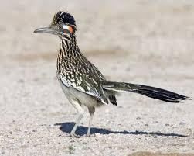
Alfa Roadrunner
Spring 2016
Newsletter

Editor: Denise Gray rvtreking@gmail.com

Officer’s Contacts:
President: Jim Godfrey- jim.godfrey@comcast.net
Vice President: Chris Mooney -chris@moonsail.com
Treasurer: Becky Godfrey - Godfreybj@comcast.net
Secretary: Barbara Leachman – barb@moonsail.com

SOCIAL MEDIA:
- Facebook.com/groups/AlfaRoadrunners
- https://groups.Yahoo.com/neo/groups/alfaseeya/info
- https://groups.Yahoo.com/neo/groups/alfaroadrunners/info

WEBSITE ADDRESS:
- www.Alfaroadrunners.net

PRESIDENT’S MESSAGE

From Dale Prichard

Ok, so here it is, my last words as your President (Past President now). It has been a wonderful opportunity being in office, as your president. The last few years have been a blast, meeting as many of you as possible in our travels.
I like to thank each one of you who made this possible.
While in office, I perform the duties of president, to the best of my abilities. I have always tried to treat people as I would have wanted to be treated. And as president, I took the duties of president seriously. In the beginning, your elected officers agreed, that we would communicate with you in a timely and accurate manner. Keeping you informed of Roadrunner current events, rallies and just plain gathering of Alfas, including the introduction of our new members.
I starter this communication with my Hot-Flashes in 2014, working with Dave Allen on the Yahoo Roadrunner group site. Then eventually creating a Roadrunner Facebook private group. Where we as Roadrunners, can share our words of wisdom, our journeys, places we visit, including the publishing your photos and videos online.
Thanks to Dave Rypma for getting this setup and published.
There are many more members I would like to thank, but I do not think I have enough room for listing everyone name in the newsletter.
So, what are DaGirls Plan? Well first, it is off to central Louisiana and then onto Florida to take care of family business. Then since we are out there we will do what all Roadrunners do. Travel, see new places, meet up with old friends and hopefully meet new ones. So, one last photo:
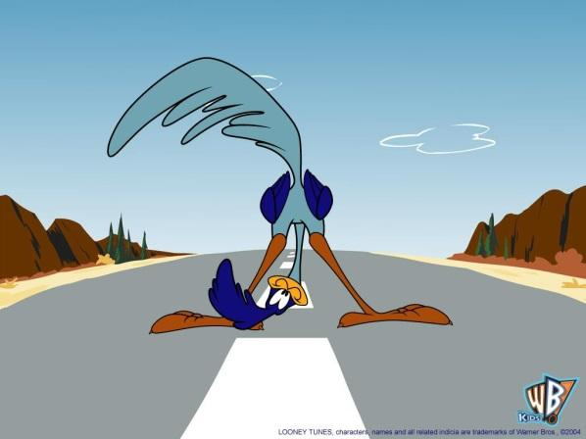

From Jim Godfrey- Words from the President and Treasurer

Greetings Roadrunners. First, Becky and I want to thank those in attendance at the Roadrunner Spring and AOC Rally’s that placed their confidence in us to be your President and Treasurer. We also look forward to working with your new Vice President Chris Mooney and your new Secretary Barb Leachman over the next year. We all have big shoes to fill following behind Dale and Susan. Their endless and unbounded energy for all things Alfa and Roadrunner cannot be topped. Thank you Dale and Susan for
what you have done for the Roadrunners over the past several years. Take a well-deserved break and safe travels.

As for Becky and I, and as many of you know, we are not full timers, and for this year at least, we will not be spending our retirement checks on diesel fuel and RV site rentals. We will instead be staying within a few days of our flag pole in Colorado Springs. Our lack of far reaching travel plans does not however diminish our enthusiasm for the Roadrunners and all things Alfa. We will do our level best to be good ambassadors for the club. For those of you that might be traveling through Colorado or planning on
spending some time in our beautiful state, please let us know and maybe we can meet up with you for a glass of wine and catch up. If you have never spent any time in Colorado and are looking for suggestions on where to stay and what to do, we’ll be more than glad to give you our recommendations. There aren’t many parts of the state we haven’t visited.

VICE PRESIDENTS REPORT
As your new Vice President, I am prepared to assume all the duties of the position – which was pretty much nothing as long as our President is doing his job. So, in the interest of being useful, I have taken over the role of Webmaster for the chapter website, www.alfaroadrunners.net .
I have updated the site with new information since our rally in Yuma, and I’ve also redesigned things a little bit. There is now a tab for past events and one for upcoming events. The tab for Resources has been updated with a few new places that have been good to the Alfa family. And, there is a new tab linking to member blogs. If you have a blog that isn’t listed and you would like it linked, or if you have a service place to recommend, let me know and I’ll add it. There is also a new tab for Technical Resources.
This page links to the famous Google Drive provided by Dale Prichard, and other technical write-ups from our members. If you have a technical write-up to contribute send it to chris@moonsail.com
Please take a look at the site and let me know if you find any typos or links that don’t work.
SECRETARIES THOUGHTS
May 2016 – What have I gotten myself into! I have such huge shoes to fill but will try and do it with grace. As your new Secretary, I will help all the other officers and members with whatever needs to be done. Chris and I have a long summer of travel planned out. We’ll be crisscrossing the US from TX to Washington state to Key West, Florida to Indiana and back to TX by the end of the year. Glad I learned how to drive! Thanks to everyone who made the rally in Yuma a great success. Quartzsite in January 2017 is being organized by some very qualified members and is sounding like loads of fun. Hope to see a lot of you there! Have a safe year everyone.
Barbara Leachman, Secretary
TREASURER
A Treasurer’s Goodbye:
It’s been a pleasure serving as your Treasurer/Membership/Merchandise contact for the past two years. I have so enjoyed meeting so many of you through our communications and in person. The reigns have moved on, but it’s a lot like giving birth and raising a child – the relationships, love and caring will last a lifetime and for that I am grateful. Dale and I will continue moving around this wonderful country and look forward to SeeYa down the road. You are in good hands with the new officers and we look forward to continuing to help grow our social group with new members and sharing time and experiences with all of you when we can.
I need to correct home locations for several new members from last newsletter, sorry for the typo, guys,
Collins Don Aloha OR
Caterson Neal & Lana Box Elder SD
Brewer John & Debra Lowry City MO

Former Treasurer: Susan Prichard

Alfa Roadrunner Chapter Night Minutes 4/15/2016
Alfa Roadrunner Meeting was called to order at 7:29
Susan Prichard moved to approve previous meeting minutes taken at the Sheriffs Dinner on 4/10/2016. The motion was seconded by Jim Collard and Dave Rypma.
The Treasurers’ Report was provided by current Treasurer, Susan Prichard.
Checking Account: $1,853.78
Savings Account: $5,553.06
TOTAL: $7,406.84
Alfa Membership is currently at 165 members, which includes 17 new members this year.
Susan Prichard mentioned that the Alfa Roadrunner Inventory had been relocated, effective today, from site 913 to site 915. Purchases of inventory can begin starting tomorrow, Saturday, April 16th.
Jerry Logan made a motion to approve the Treasurers’ Report. The motion was seconded by John Kurz.
The motion was approved with one no vote.
Unfinished Business/New Business:
First:
Ray and Maryanne Balzer discussed the Quartsite 2017 Rally, as the Wagon Masters
The rally will be in Quartsite, of course, from January 21, to January 29, 2017. They have already been busy in planning the rally and have handouts to provide to each coach that may have an interest in attending.

Second:
Jim Godfrey presented to the Roadrunners, that the South Loafers had approached the Godfreys to be co-Rally Masters for next year’s AOC National Rally. The AOC Rally is currently set to occur in Tuscon, Arizona. Jim asked the Roadrunners to please raise their hands in a show of support for the Godfreys to assist as Co-Rally Masters for the 2017 AOC Rally. Many hands were raised in show of support.
Third:
Susan Prichard discussed the possibility of a Fall Rally in Albuquerque, New Mexico, as a group of volunteers to assist with their annual Balloon Festival. There was a show of hands for those Roadrunners that may have an interest. Please follow-up with Dale and Susan Prichard if you would like to be involved in this year’s Balloon Fest effort.
Fourth:
Brian Hood provided feedback regarding the Treasurers Audit Committee Report. He proceeded to report that all was found to be good. Dale Prichard provided thanks to the auditors who volunteered their time to check through the Treasures’ Books.
Fifth:
Curt Wetzel and Gene Lasiter moved that the Roadrunners move forward with the nomination of the remaining officer positions.
Vice President:
Barb Leachman made a motion to nominate Chris Mooney to the position. The motion as seconded by Pat Bustamonte and Jerry Logan.
Secretary:
Chris Mooney made a motion to nominate Barbara Leachman to the position. The motion was seconded by Dan Sheppard and Jim Collard.
These nominations completed the nominations for officers for 2016. Jim Godfrey was nominated for President and Becky Godfrey was nominated for Treasurer at the Sheriffs Dinner on Sunday, April 10th.
Nominations were closed and a vote was taken. All nominees were unanimous approved by the members.
Sixth:
Dave Rypma provided an introduction of Alfa Roadrunner facebook website. New members were strongly advised to take a look at our resources which are provided for them on the website. Jim Godfrey mentioned that perhaps we should have a chat forum available to members that may like activities such as NASCAR, Bird-watching, Skiing, etc.
Val Nelson moved that we adjourn the Alfa Roadrunner Chapter Meeting. Joe Hughes seconded.
The meeting was adjourned at 7:56 p.m.

2016 SPRING ROADRUNNER RALLY/AOC RALLY, YUMA, AZ
From: Susan Prichard
What a wonderful time we had. The venue was good and the resort and staff was very accommodating as we faced several rain delays and changes to our schedule as a result. Evenings were fun as people milled around on the streets visiting from coach to coach. Our “Swap Meet” area had folks returning often to see what new had arrived from one coach and was looking for a “new home” in another. Lots of coach improvements were made by owners helping owners and vendors on-site. Many evenings were spent socializing and sharing as new friendships were formed and old ones reignited. At our Farewell dinner it was announced that we have volunteer Wagon Master’s for 2017 and 2018 AOC Rallies. 2017 may be in Tucson, so hoping to SeeYa there.
AOC 2016 UPDATE:
The annual Alfa Owners Club Rally and Roadrunner pre-rally were held in Yuma. Of 88 rigs attending one or both rallies, 42 were Roadrunners, and 3 new rigs signed up as Roadrunners at the rally!
Below is a thank you note received by Dale and Susan:
Dale & Susan Prichard and Della & Tilly
My wife and I were the lucky winners of this year’s AOC rally basket from the RoadRunners chapter and we want to say THANK YOU for it. The gift cards will not go to waste. Please forward our THANKS to all RoadRunners and happy trails to all.
SouthLoafers
Jim & Yvonne Beard
TECH TALK
From Ray Balzer
Has your Thunking lost its vigor? If you have Big Boys now, you don't need to read this. Otherwise, new solenoids may be right for you. If you have a Xantrex Pathmaker (ours is under our step in our 2006 See-Ya!), it might be slowly failing. Learn how to tell; and learn about replacing the solenoids or even the entire unit, as well as how to enhance it for high voltage operation. And be sure to consult your RV doctor if you have a stuck solenoid that lasts for four hours.
Full article link: http://alfaroadrunners.net/tech-resources/

From Joe Hughes:
Hello Roadrunners,
Here in Salt Lake City at a KOA. Great location. Has 120 PSI water pressure so regulators are necessary. Had my Black Tanks cleaned at Yuma and want to keep them clean. Thought it would be a good idea to flush from the control panel into the black tank with the 120 PSI. I called Martin at Leisure Coach and he told me that would be a NO-NO. The hose in the Alfa is only rated at 80 PSI !!!!. Cannot count the times Martin has saved me from disaster. Joe Hughes
PS. Hard to believe Dale did not cover that in one of the seminars!!!!

NOW, ONTO THE FUN, LET’S HEAR WHAT IS GOING ON WITH OUR FELLOW ROADRUNNERS:
Chris Mooney and Barbara Leachman
The MoonBus has had a busy couple of months. Last year we moved from Houston to Phoenix in two days. So this year, after spending four months in the Houston area, we took six weeks to get from TX to AZ.
Our travels took us to a Parrothead music event in Port Aransas, TX, then on to South Padre Island for a few days. From there we went to the San Antonio area where we played tourists at The Alamo, The Riverwalk, Natural Bridge Caverns, and New Braunfels. From there it was on to the Austin area, where we poorly timed our visit with South By Southwest, a huge two-week festival that made the city very busy. From Austin, we headed west with stops in Johnson City, Fredericksburg, and Luckenbach. Next was a week in far west Texas in the Big Bend area, including Marfa, and a drive along the Mexican border between Terlingua and Presidio. Next up was New Mexico, with visits to Carlsbad Caverns, Roswell, White Sands, and Las Cruces. Next up was a week in southern Arizona visiting Sierra Vista, Bisbee, Tombstone and Karchner Cavern. Then it was on to the AOC and Roadrunner rallies in Yuma.
We’ll be spending the rest of April and May in Arizona, and then doing a western US tour for the summer.
From Bob and Denise Gray:
Our travels took us from Sun City AZ to Fontana CA for a repair to our big slide in March. Leisure Coach Works (formerly Alfateers) had to completely rebuild our big slide. The floor and the roof were in bad shape. Evidently we had water intrusion, which warped the ‘box’. They also replaced the P molding, rollers and some of the ramp. During the repair, we stayed at the Thousand Trails, Wilderness Lakes, in Menifee CA. Luckily, we had a coupon for a free 7 nights in a cabin, and then we were able to extend for another 4 nights, at half price, giving Jon and his crew 10 full days to work on the rig.
We left Fontana and moved to Jamul CA, staying at the Pio Pico Thousand Trails and visiting San Diego. Where could not get internet or cell phone. Plus the sewer connection was 2.5 inches, which is ½ an inch smaller than standard. The connections they had in the store did not work. Plus the place was really noisy, so we moved to the Elks Lodge in Chula Vista and toured San Diego. All of this prior to the AOC Rally.
From Frank and Deana Jones:
We are currently back in Kansas City, MO area visiting family, friends and doctors for annual visits.
This winter we found a few places new to us that I want to share with the group. You may want to add them to your trip plans for next year if you go to the SW.
In February, we stayed at Fountain of Youth north of Niland, CA. They have a dry camp area at the top of a hill. It is nicely arranged with distant view of the Salton Sea & the resort with palms below. There is a very nice bathroom/shower in the area & trash. There is area for wash your toad & a dump area on the hill also. There are RV hookups but the dry camp area is great & cheap at $118/wk. and yet get to use all the amenities of the resort which includes spas, 3 different pools, small café, all kinds of activities. They have dances, shows, jam groups, quilting groups, 4x4 drives, etc. You can take day trip to the Salton Sea & Slab City & Niland, CA. Quite a few Canadians were up by us. Check it out.
We found a little campground in Blythe, CA called Hidden Beaches by small river. We parked forward for view. Was able to use our Passport America card. Good place to camp quiet during the week & catch up on email, reading, etc. You can fish but need CA license.
While we were getting our heat pump worked on by Gene’s AC & RV Repair place in Mesa, we found a little café Mickey’s Café on Main in small, older strip mall. Nothing special so surprised to find the best Reuben & curly fries EVER. Too bad we didn’t find it sooner. Their other food may be tasty also. Worth a stop.
March 6th, we rode the light rail from Mesa thru Phoenix (expanded further in a couple of weeks) & stopped at the Heard Indian Museum. They happened to have an Indian festival going on outside with PowWow dances & quality art. Figure that this is annual festival in early March. We did a short tour & plan to go back to museum & also the festival if we are in area at the right time. We bought a day pass so next time we may get off & on some. Nice overview to see Mesa, Tempe, Phoenix & beyond. Reliable times & quite a few stops. Cheap. And no car to deal with.
In March, we camped at Camp Verde at Rancho Verde RV Resort. There is another one nearby being renovated. From here we took day trips to Jerome, AZ, Redrock State Park & Sedona & Cottonwood. We could have stayed longer & hiked more in Redrock SP. And if you have never been to Jerome, you might want to spend 2 days there. They have music on weekends & many boutiques & art galleries. Likewise, Sedona takes several days but we didn’t do any shops/galleries since we had been there before. We ate at the Barking Frog—interesting & food good. Also we visited 2 National Monuments/Parks called Montezuma Well & Castle. Castle is the best, short hike to see the ruins in a hill, pretty hike. We extended our stay in Camp Verde to attend the Archaeology, Wine, Pecans, Indian Arts Festival held on weekend of March 19th & will probably be there again next year. The Archeology Center is interesting about the areas & primitives living there centuries ago. At the Festival the center had films & lectures. At the Indian Arts Festival, the artists were showing the processes to create art in the olden ways. Quite a bit of Hopi items. This was probably #1 or #2 on our list this year. The other was going to the Musical Museum Instrument close to Scottsdale, AZ.
One unexpected thing occurred this winter, I struggled some with living in motor home all the time. We have been full-timers since 2002 or 14 years and I am beginning to want to settle down part of the year. I also got where seeing new things was not as desirable to me as it had been for years. Imagine that. But I guess we all get to that point at some time or other. We are negotiating how we can meet each other’s needs at this point. One thought is that maybe we need to settle down some next winter & not move around so much as we have all 14 years. So stay tuned as we resolve the kinks.
Have a good summer, fellow RoadRunners,
Joe Hughes and Val Nelson
Hello all,
Val and I are on our way to Alaska. We have signed up with MY TRIP JOUNAL to keep a log of our trip. The plan is to drive 200 to 300 miles and then stop for 4 days and explore the area we are in. With my trip journal we can upload pictures and commentary about our trip. It seems to be working that each stop gets one write up so a posting is made every 4 or 5 days. I have included some samples of our postings so far.
If you are interested in following our trip email me a request( joemhuzs@gmail.com) and then I will enter your data. My Trip Journal will send you an email for you to allow receiving posting from us. When you approve that you will be connected to our journal log. Examples of entries are below:
April 17, 2016
Our first stop was at Northshore Resort in Needles, California, a lovely spot on the Colorado River. At this time of year our shady spot is very welcome - today's temperature is 93 degrees.
Monday the 18th, we decided to explore the area, so we started at Topock and drove north on Historical Route 66 to the town of Oatman, an historical "touristy" town originally formed due to a local gold strike. Burros walk the streets eating anything the tourists will feed them! Many unusual shops and an old hotel dating back to 1902. We found the whole town had a fun party atmosphere which will be enjoyed by about 3000 of the 50,000 bikers who come to Laughlin later this month. The drive to Oatman and back is a challenge to motorcyclists and is limited to vehicles less than 40 feet in length due to the tight turns and sharp drop-offs. After going over Sitgreves Pass (3523 feet) and then Union Pass (3625 feet) we had lunch.
We continued thru Laughlin and Bullhead City, two gambling meccas where we saved our money, but the 50,000 bikers expected at month's end may not be so frugal. Returned on 95 back to the park and enjoyed drinks on the patio overlooking the river and watching the martins eat mosquitos instead of us.
The flow of the Colorado at this point is amazing. Would not be able to swim upstream if you are more than 15 feet from shore. The river is about 1000 feet wide. Docks are all the floating type to compensate for varying river heights. Across the river are some very nice homes.
All in all a very restful first stop with time to get some small maintenance items done.
We left the Northshore RV Resort in Needles, California, stopping in Las Vegas to get a part for the car connector, "The Blue Ox" and drove through the northwest corner of Arizona, which is extremely scenic (think of the magazine "Arizona Highways"). We got to the St. George/Hurricane KOA about 2:00. It is a lovely spot with a huge cliff behind us and gorgeous redrock rising in the west. However, because of the rock formations, we are in a "bowl" that doesn't receive phone signals or WIFI. Everyone in the park appreciates the beauty of the spot and the lovely heated swimming pool, but realizes we are in a communication desert. Trips to McDonalds in Hurricane (9 miles away) are necessary to reach the outside world.
April 19, 2016
The area is very historic. Leeds, just down the road has a Civilian Conservation Corp (CCC) camp-think 1930s-that was restored as an Eagle Scout Project in 2011. Just down the road from the KOA is a Utah State Park, Quail Ridge State Park, which is a lake created by a dam that is the water reservoir for Hurricane, Utah, the closest town. Recreational activities are abundant in this area including off-road biking, ATVs, and of course, boating and camping.
Friday we went to Zion National Park, where we drove on the Zion Mt. Carmel highway (State road #9) which goes through Zion National Park. The road is absolutely spectacular with the different colors of the rock rising on either side.
We went back to Zion on Saturday, which was Joe's birthday. We took the shuttle bus that drives the Zion Canyon Scenic Drive, a north-south view of the park where cars are not allowed. There are 8 stops the shuttle makes, and one can get on or off at any of them, with frequent shuttles so the wait is never more than a few minutes to move on. We rode the bus out to the northern end, an area called the Temple of Sinawava (picture #1). One may walk along trails or just sit, as Val did, admiring the waterfall of the Virgin River, which has done all the carving of this gorgeous canyon. If you look closely at picture #2, which is an out crop of rock that is not unusual for Zion, you will see a small dot about 1/2 way down. Camping is not allowed in Zion, but two creative souls managed to get around the rule by climbing up the rock and attaching a sleeping platform where they camped overnight. It was getting windy on Saturday and the bus driver said they were coming down soon.
One of the trails from Shuttle stop #6 leads to the Weeping Wall, which is where a river coming down through the rock meets an obstacle it cannot penetrate and seeps out to the rock face of the canyon. Joe was not moved by the weeping but the view of the canyon from there was beautiful.
From Mike & Rhona Smith:
Here is our winter adventure. While we did not travel with our Alfa this past winter we did travel to see my son in Nelson, New Zealand. Our trip started on the 25th March flying out of Vancouver BC Canada on Air New Zealand 23, flying to Auckland New Zealand. This is a 14 hour non-stop flight on a 787-200. We were lucky and were given an upgrade to premium economy. We arrived in Auckland at 05:30. My son met us with 3 of my 5 grandkids Ben, Katlyn & Amy. We went to my cousins Lynda house for breakfast; I had not seen her in 46 years. We spent the night in Auckland catching up on much needed sleep. Auckland is 19 hours ahead of Vancouver so we had arrived on Monday, after leaving Vancouver Saturday at 19:30hrs.
The following day we left for Nelson on the South Island of New Zealand (542 miles).
We stayed at a Top 10 RV resort with camping cabins and a swimming pool with a bar in the center.
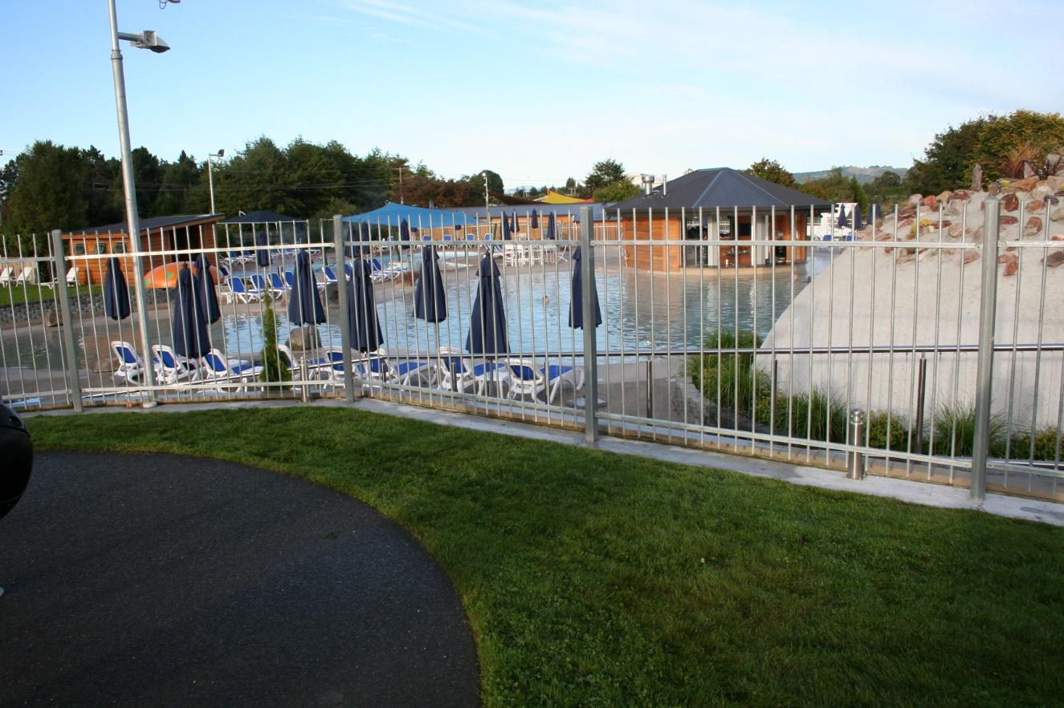
We drove to Wellington New Zealand, which is the capital, and visited the war museum which is dedicated to the New Zealanders that died in the great war of 1914 to 1918.
That night we drove up to Foxton to have a barbecue with my friend, Athol, that I had grown up, with whom I had attended both Elementary and high school with, and had not seen since I left South Africa back in 1973. We amazed the grandkids and my son with all the trouble we got into as kids as well as our time in the South African army (back in the day of draft service). Amazing we are still alive with some of the stuff we did. The next day we took the ferry from the North Island to the South Island, a 3 ½ hour trip.
Here is the road passing from one valley to the next. It would be fun to drive the Alfa on these roads!
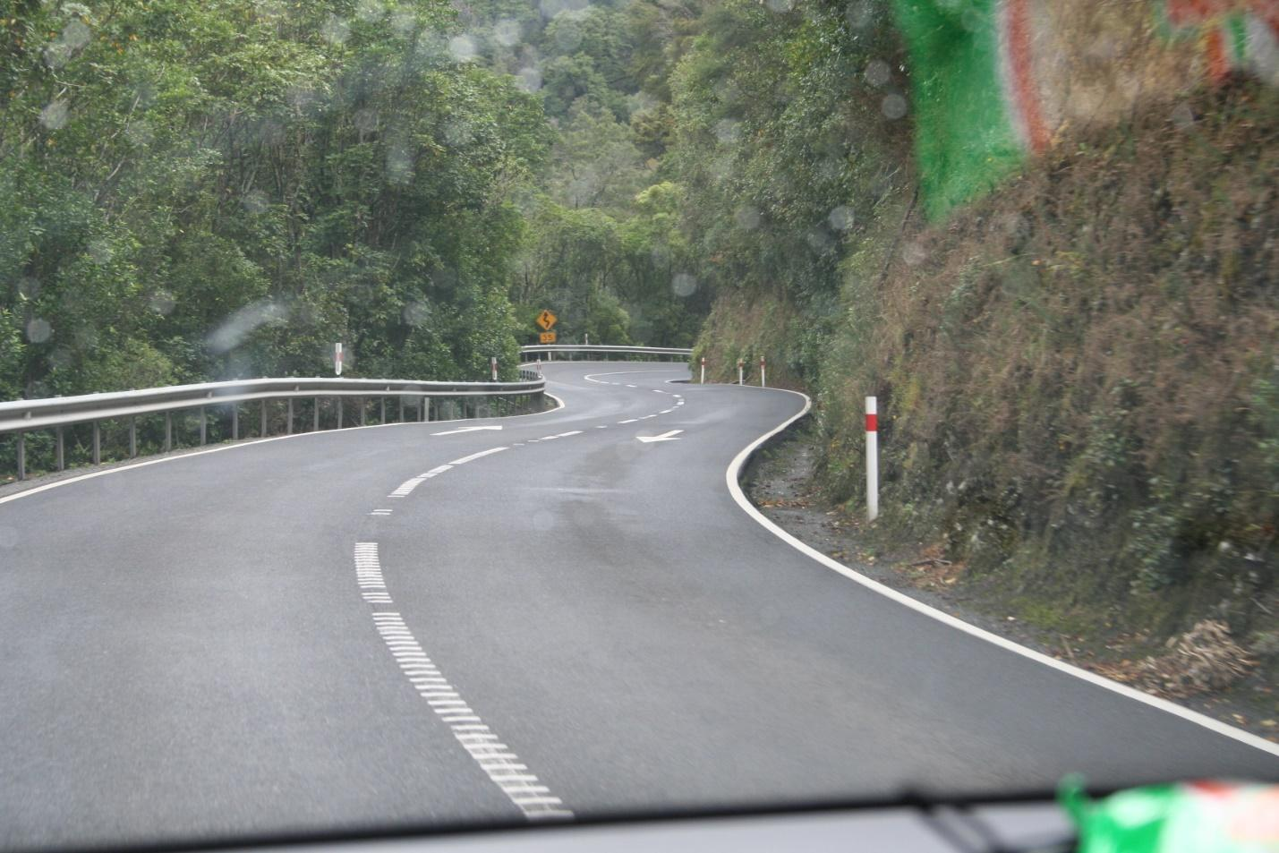
We took a day trip to the east side of the island to dip our feet in the south Pacific, visited our son’s farm and took the grandkids fishing.
We flew from Nelson back up to Auckland a 1:45 flight and then a 14hr flight back to Vancouver. Arriving the same day we left New Zealand (depart 20:05 on the 30th April arriving 14:30 on the 30th April). We stayed the night in Vancouver to get our heads back to BC time zone. We then drove up to our place at River Side RV resort where we have our lot. If anyone is in the area this summer feel free to drop by. We are at 98-4354 Highway 3 Keremeos BC
Mike & Rhona Smith 07 Alfa 74505
INTERESTING PLACES TO VISIT!
From Denise Gray :
When staying in South Bend Indiana, in 2014, while having our Alfa reskinned and painted, we took numerous day trips. One that was very interesting was to the “Auburn, Cord, Duesenberg Museum” in Auburn IN. If you are ever in this area, this is a fascinating museum to visit. The museum is located in the original art deco administration building. The cars are fantastic. All are individually owned but reside in the museum when not off at a car show. Did you know that Indiana was a very important automobile manufacturing area at the dawn of the automobile? Well now you do!
AIBF VOLUNTEER RALLY, SEPT. 28 OR 29 – OCT 9 OR 10TH
From Susan Prichard:
http://www.balloonfiesta.com/operations/volunteering
Navigator RV Space Request form: http://www.balloonfiesta.com/uploads/Navigators/Navigator%20RV%20Request%20Form.pdf Note on bottom of form: Entering as a Group/Alfa Roadrunner
Join Dale and I as we experience our first Albuquerque International Balloon Fiesta (AIBF). Roadrunners will be volunteering our time during this event and will receive a number of perks for our willingness to do so as Navigators. Perks vary depending on number of volunteer hours/shifts you put in. There are approximately 40 areas where volunteers will be needed, each of us can choose what interests us most. For those with disabilities or limitations, the Information Booths offer a place where you are able to sit. Everyone will need to complete on-line training (4 videos - approx. 2 hours total with simple quizzes at the end of each of the four videos). Please review the link above with more information. Let me know you are interested, registered and have sent in your RV parking request (dry camping). The sooner the better. Rvgrandma01@gmail.com. Looking forward to sharing this with about 10 fellow Roadrunners. Call Susan with questions: 480-495-4645
2017- QUARTZSITE
From MaryAnne Balzer:
Come join us in Quartzsite January 20 – January 29 and celebrate 30 years of Roadrunner life on the road! That’s right; the Alfa Roadrunner’s Club was founded in 1987!

The 2017 year continues Alfa clubs’ recent anniversary celebrations. So in 2017 let’s see how many ‘long-timers’ and new-comers we can gather at our traditional camping location in the desert of North LaPosa BLM, just south of the Quartzsite junction on Highway 93. It’s time for a grand desert celebration!

Come witness beautiful sunrises and incredible sunsets. Visit the big tent RV show as it comes to life as if by magic—filled with products galore. Be amazed by the quirky cultural experience that is Quartzsite. Be in awe of the desert experience. Be moved and inspired by the willingness of all Roadrunners to pitch in; making the desert rally a great time for everyone. Be swept away by the fun of it all, be a kid again. Come play and fall in love with the unique lifestyle. Whether you are full-timer, part-timer or vacationer come join us in January!

We are working on a great line-up of rally activities for 2017. Venturing outside camp group activity ideas include outings both out of town to Crystal Hill for quartz crystal hunting; and visiting the numerous in town quirky and unique attractions found only in Quartzsite.

In-camp time may be spent in many ways. The Wagon Masters will coordinate numbers of seminars, groups and get-togethers as selected with the attendees. From tech talks to desert walks to crafting to open coaches, to social hours and more the Quartzsite rally is unique as events are in the hands of the attendees.

Planned meals will be handled in several ways. Stay tuned as the Wagon Masters arrange some creative fun options to celebrate our 30th Anniversary. Variety of meals will include some provided as part of your camp fee, or coordinated attendee special event meals, or small group social gatherings. And, of course, there will be Anniversary cake!

Watch your email for special Quartzsite news blasts as fall approaches for sign up and further information. Also, watch the newsletter for the rally column. In addition, please be sure to check the Roadrunner web site at www.alfaroadrunners.net for updated rally news and information. And always, if you want to talk with Wagon Masters Ray and MaryAnne Balzer please contact us via email, phone or text. We’d love to talk with you.

See you in Quartzsite!

INTERESTED IN BAHA MEXICO?

From Kathy Hewlett:
Roger and I are thinking about driving our motorhome down the Baja next winter (2017) and would like to hear from other Roadrunners who have taken the trip or are interested in going with us. We would love to “talk” to friends who have made the trip and hear the pros and cons. We are wondering about safety, gas, campgrounds, language barriers, food etc. We have another couple, not Alfa owners, who are full timers that would like to go with us and we would welcome others to travel with us. You can contact us via email or phone:
Roger Hewlett – roger.hewlett@gmail.com 210-573-9847
Kathy Hewlett – Kathy.hewlett@gmail.com 210-884-1245
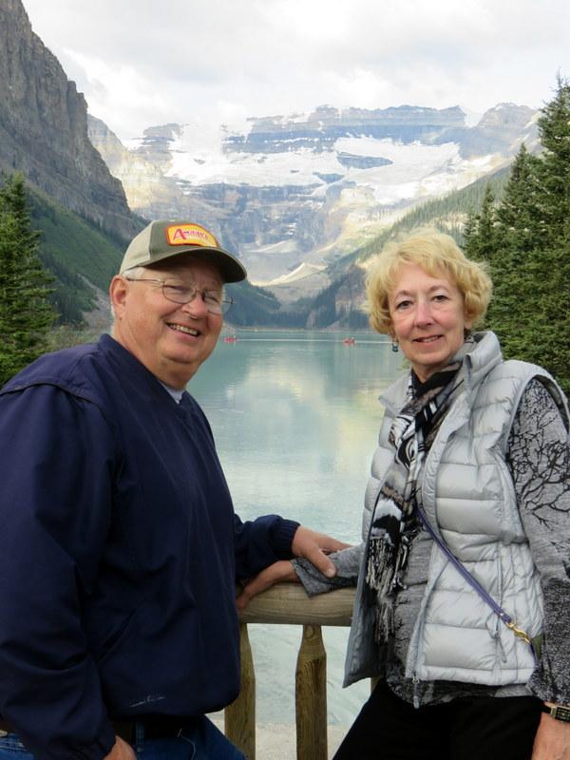

AOC Rally 2017

We have Wagon Masters! Dates and location to be determined.

Wagon Masters: Andy and Brenda Bober (South Loafers)
Co-Wagon Masters: Jim and Becky Godfrey (Roadrunners)

Thank you to these terrific volunteers!!

GET-TOGETHERS
Mesa AZ
MOAB (Mesa Owners Alfa Breakfast) will be Saturday, February 13th, March 12, and April 9 ( for those not at the AOC rally!), at the Golden Corral located on Power Rd and McKelliips Rd in Mesa, AZ 85205 starting at 8:30 am. Please wear your Alfa red shirts or your Park name tags. If you have any questions please call John Filipczak: 612-965-5762 or email me: johntsr641@gmail.com
Yuma, AZ
The Yuma Alfa Owners Breakfast is the second Monday of the month, November through April. All Alfa owners, past owners, and want-to-be’s are invited. It’s a great time to meet and greet, catch up on the goings on, and discuss the care and feeding of Alfa MH’s and Fifth-wheels.
The Yuma Alfa breakfasts are held at the Copper Miner Restaurant (formerly Mi Fajita Restaurant), 11375 Foothills Blvd., Yuma, AZ. (The restaurant is under new ownership and management. They offer the breakfast special that a lot of folks like.)
If you’re in the area we hope you’ll join us for the breakfast. If you have questions or need directions please give us a call. And please pass the word.
Mel and Judi Kirkland
‘03 SeeYa 40’, towing ‘15 Caddy SRX
928-342-7374

FOR SALE
Brand new (never out of the box) custom make ADCO Sunbrella Cover for a 40’ Alfa. $500. Located in Mesa AZ. Owner no longer owns an Alfa. Contact. Steven Rector sfrector@gmail.com
FROM THE EDITOR
The next newsletter deadline will be August 1, but you can send me articles whenever you want and I will keep them for the next newsletter.
Suggested ideas:
- What you have been up to!
- Interesting places that you have visited.
- Great RV parks where you have stayed!
Denise rvtreking@gmail.com.

